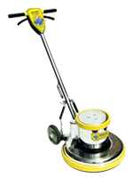

Used for spray buffing, scrubbing, stripping, shampooing and bonnet cleaning.
Motor Type: 1.5 HP A/C, 2 Capacitors, 15 Amp
Brush Speed: 175 RPM
Optional: Unicorn Weight Kit (UWK) and Solution Tank (SST-4)
Safety Switch Box
6” Non-Marking Wheels
Non-Marking Bumper
5 Year Warranty on Motor & Chassis
1 Year Service Labor Warranty
Triple Planetary High Torque Transmission

