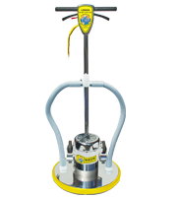

Orbital sanding at 1725 OPM with no torque gouging, swirling or vibrations.

Powerful induction motor is completely enclosed allowing a long life for brushes and commutator.
16” sanding screen lays under the pad driver fit with a standard 16” scrubbing pad.
Collect sanding dust with a Backpack Vacuum by adding an optional Sanding Dust Kit.
Free-floating, chromed steel handle includes an easy kick release and an automatic locking system.

