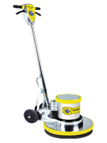

Labor-saving dual speed, specifically designed for cleaning, scrubbing or stripping floors.

Brush Speed: 175/300 RPM Dual Speed
Motor Type: 1.5 HP, 66-Frame D/C Rectified Motor, 13-15 Amps

6” Non-Marking Wheels
Non-Marking Bumper
5 Year Warranty on Motor & Chassis
1 Year Service Labor Warranty
Triple Planetary High Torque Transmission

