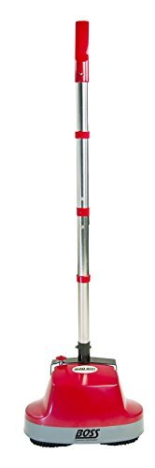
Gloss Boss Buffer - buff, polish and protect hardwood, vinyl, tile, laminate and concrete floors keeping them sparkle clean. Unlike many commercial grade buffers, this one is lightweight (7 lbs.), easy to push and has no drag. Simply spray the desired area and let the dual nylon brushes do the rest.
470 rpm
10" Cleaning path
18' 3-Wire cord
Includes two washable microfiber pads
1 Year warranty

