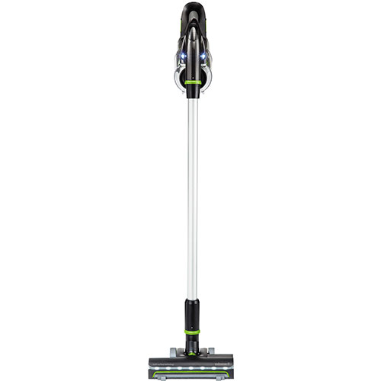

Combining powerful performance and lightweight versatility for total home cleaning. As a powerful stick vacuum, the motorized brush roll and suction power cleans carpets and bare floors with ease. The highly versatile unit features removable hand vacuum allowing you to easily spot clean above floors while you vacuum. The lightweight and maneuverable motor-in-hand design makes it easy to handle and control.
- Cordless Freedom and up to 20 minutes of run time with 22V lithium ion battery
- Converts to powerful hand vacuum with variety of tools
- Extension wand to reach up high and into corners
- Bright LED lights to see dirt where it hides
- Ultralight and easy to use at 5 lbs and ergonomic handle with swivel steering
- 2-year limited warranty

