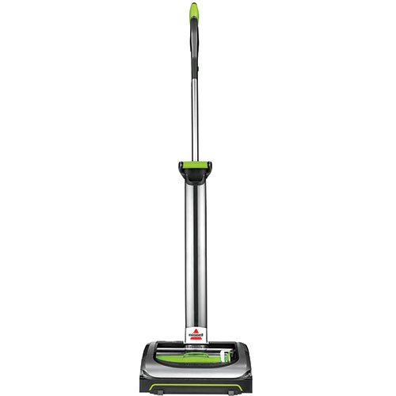
Meet the Lightweight & Powerful AirRam Cordless Vacuum. Equipped with a 22V Lithium-ion battery, this cordless vacuum delivers up to 40 minutes of powerful, fade-free suction across carpets, hard floors, and area rugs. The AirRam is ultra-light and easy to use weighing less than 1 pound in use, and with swivel steering and a lay flat handle, it maneuvers under and around furniture with ease.
- 40 Minutes of Cordless Power – Removable Lithium Ion battery for 40 minutes of fade-free power and cordless convenience
- Lightweight & Compact – This cordless powerhouse weighs less than 8 pounds and has a collapsible handle for easy storage
- Powerful Multi Surface Cleaning – Innovative power foot design and multi-surface brush roll delivers high performance cleaning on hard floors and carpets
- Maximized Maneuverability – With swivel steering and a lay flat handle, Air Ram maneuvers under and around furniture with ease
- Easy Empty Dirt Bin – Removable dirt bin with built-in Easy Empty slider that pushes out debris, hair and dirt for a mess free empty
- LED Lights – Bright wide range LED lights illuminate hard floors to assist in seeing fine dirt and debris for effective cleaning

