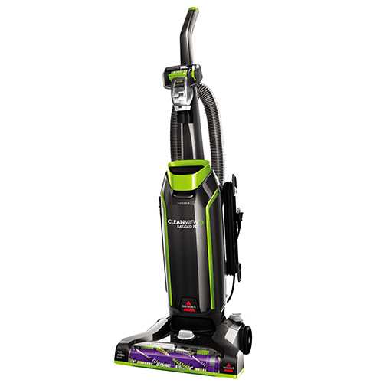

You can clean up easily with the BISSELL® CleanView® Bagged Pet Upright Vacuum. The Premium Allergen Filtration with Febreze® eliminates odors and freshens while you vacuum. This vacuum is equipped to make cleaning up after pets easy. The Triple Action™ Brush Roll loosens, lifts and removes embedded dirt and pet hair from multiple surfaces. The Flexible Pet Crevice Tool cleans hard-to-reach areas that require bending to get to. It is lightweight and easy to maneuver with powerful suction to clean all kinds of messes pets make. The BISSELL® CleanView® Bagged Pet Upright Vacuum is a must-have for any pet parent.
- Premium allergen filtration with Febreze® pet odor Eliminator style 7 bag
- Triple Action™ Brush Roll loosens, lifts, and removes embedded dirt and pet hair from multiple surfaces
- Lightweight with powerful suction and great performance so it's easy to clean around your home
- Flexible pet crevice tool is great for getting into hard-to-reach areas and versatile convenience with stretch hose and on-board tool storage
- 27 foot power cord
- 3 - year limited Warranty

