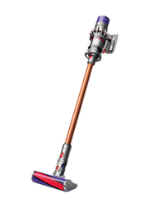
The Dyson V10 vacuums come stock with
Torque drive cleaner head
The Torque drive cleaner head– our most powerful yet.
Soft roller cleaner head
Engineered with soft woven nylon and anti-static carbon fibre, for hard floors
Mini Motorized tool
Great for cleaning smaller surfaces, upholstery and stairs
Mini soft dusting brush
With soft nylon bristles to clean delicate surfaces and fabrics
Combination tool
Two tools in one - brush and wide nozzle. For simple switching between tasks
Crevice tool
Designed for precise cleaning around edges and narrow gaps.
Docking station
Wall-mounted dock to recharge your vacuum and tidily store tools
Charger
Charges your vacuum with or without the docking station

