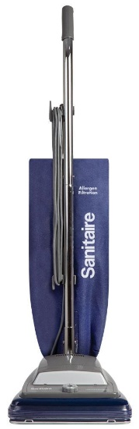

With a history of reliable service, the S645 shines as a great upright with a headlight and extended life commercial motor that is warranted for 10 years and lasts 5 times longer than the average household version

