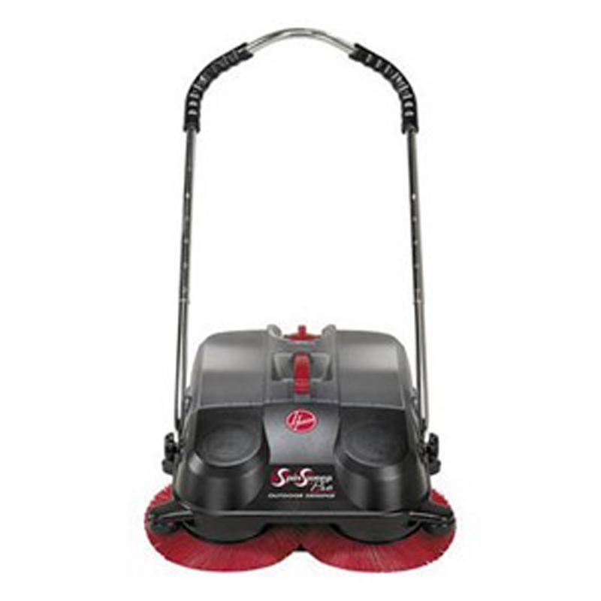
Perfect for picking up grass clippings, mulch, leaves, gravel and litter from sidewalks, driveways, storefronts, garages and more.
Motorless, no cord, batteries or fuel/oil mixing.
Environmentally friendly, no air or noise pollution, or energy consumption.
Swivel casters and wall guides for smooth maneuvering.
Heavy-duty, height-adjustable brushes and handle, with ergonomic design.
E-Z Empty translucent collection bin can be emptied with one hand.
Easy assembly.

