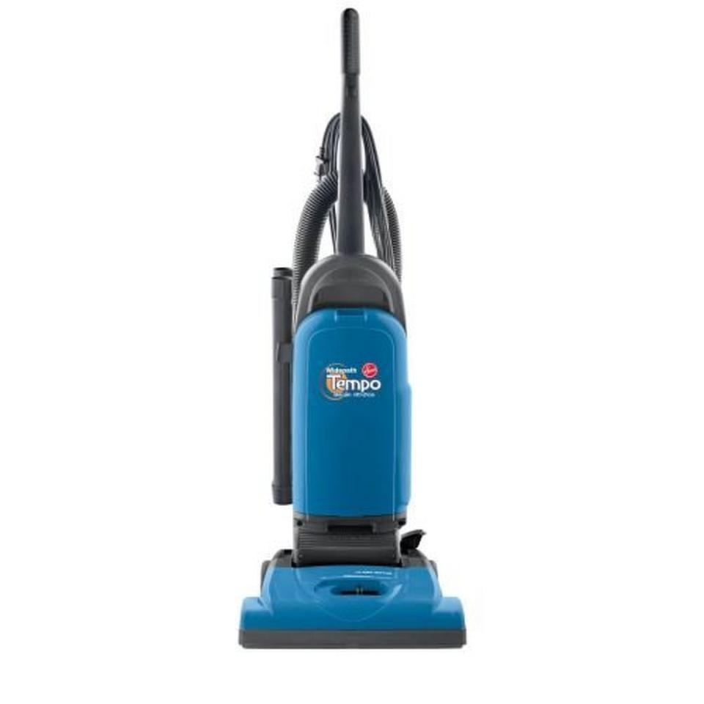
The Tempo Widepath Upright allows you to clean surfaces in fewer passes with the 15-inch Widepath nozzle and has the power you need for quality cleaning.

Features
- Allergen Media Filter - Traps 99% of dust and pollens down to 5 microns
- Rinsable Filter - Rinse and reuse for long-lasting convenience
- Powerful Reach - 25-foot cord extends room-to-room without the hassle of unplugging
- 5-Position Height Adjustment - Settings easily adjust from deep carpet to hard floor surfaces
- Wide Cleaner Mouth - Cleans up dry spills quickly
- 1-Year Limited Warranty

Includes
- 2 Extension Wand
- Crevice Tool
- Upholstery Tool
- Dusting Brush

