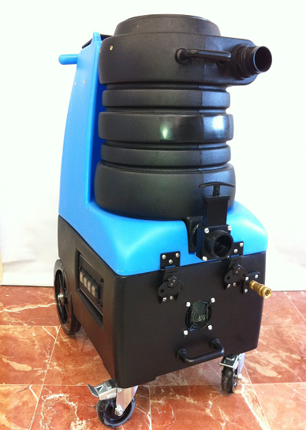
Extreme Portables
(2) 3-Stage Hi-Performance Vacuums
Parallel Configuration
2" Plumbing for 2" Vacuum Hose
200 CFM, 140" Water Lift
(75% of the Power of an 18HP Truckmount)
800 psi Pumptec Pump 1.8 gpm
Regulator Valve 100-800 psi
1500 psi Gauge
100% of Truckmount Pressure
10 Gallon Tanks
12" Rear Wheels, 4" Front Casters
Cooling Fan
1 Yr. Guarantee, Parts and Labor

OP-57

