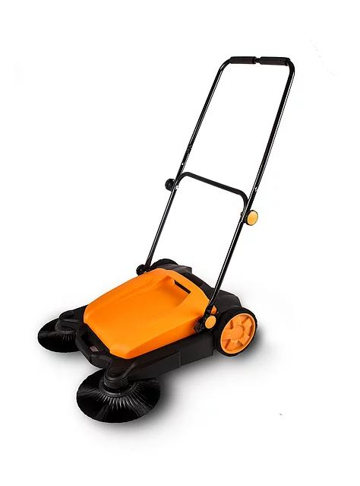
Best-in-class cleaning performance
Cleans up to 5X quicker than a conventional broom. Sweeps up to 19,000 square feet per hour
Human-powered sweeper mechanism requires no electricity. Easy to push with minimal physical effort, weighs only 22 pounds
Ergonomic handle, flexible and comfortable. Two-stage height adjustment for personal preference. Handle folds down for storage
4.2 Gallon (16 liter) onboard waste container is simple to empty and keeps you from getting dirty in the process. Easy disposal, no contact with the dirt
Perfect for cleaning garages, driveways, sidewalks and storage areas. Clear your garden paths, patios and driveways up to five times faster with the sweeper

